1. 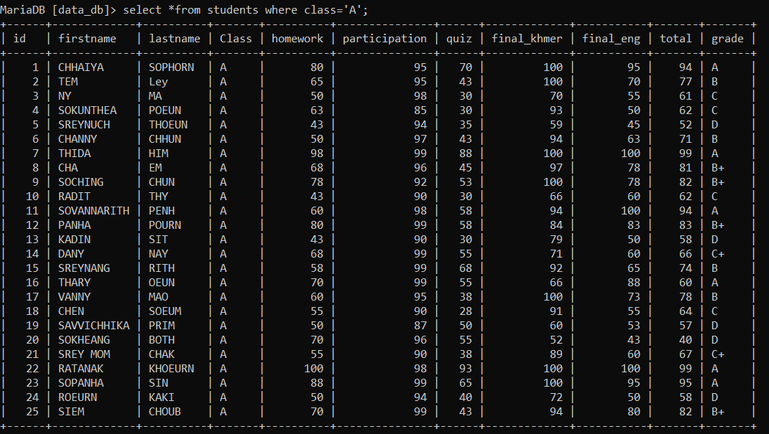Get all students from class A
2. 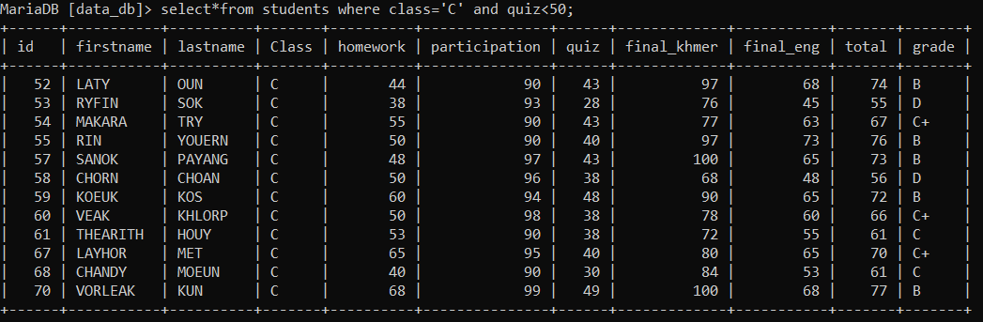Get all students who failed quiz in class C
3. Get all students who need to do make up exam all class

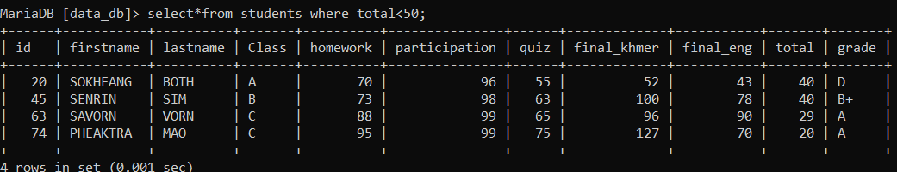

1. Get all students who get score between 80 – 100

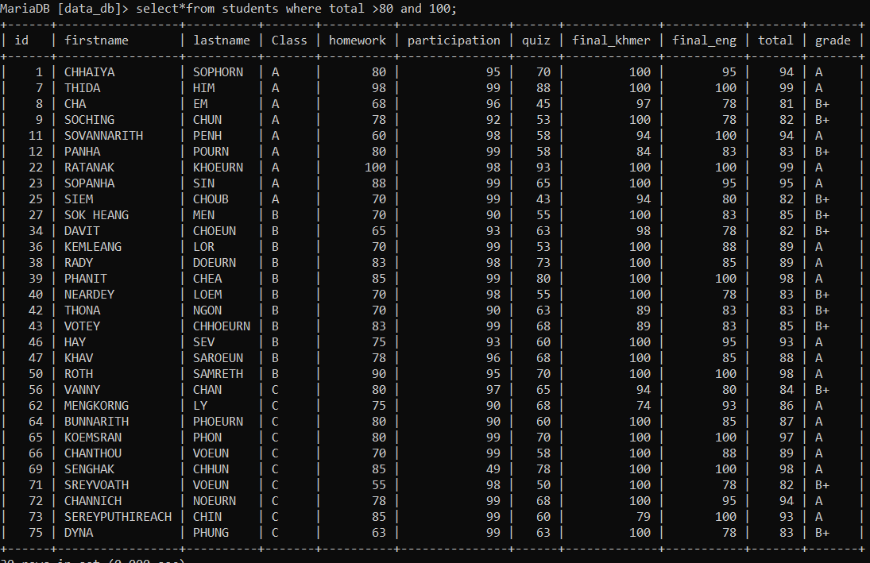

1. Get all students who have last name finished with letter “N”
2. 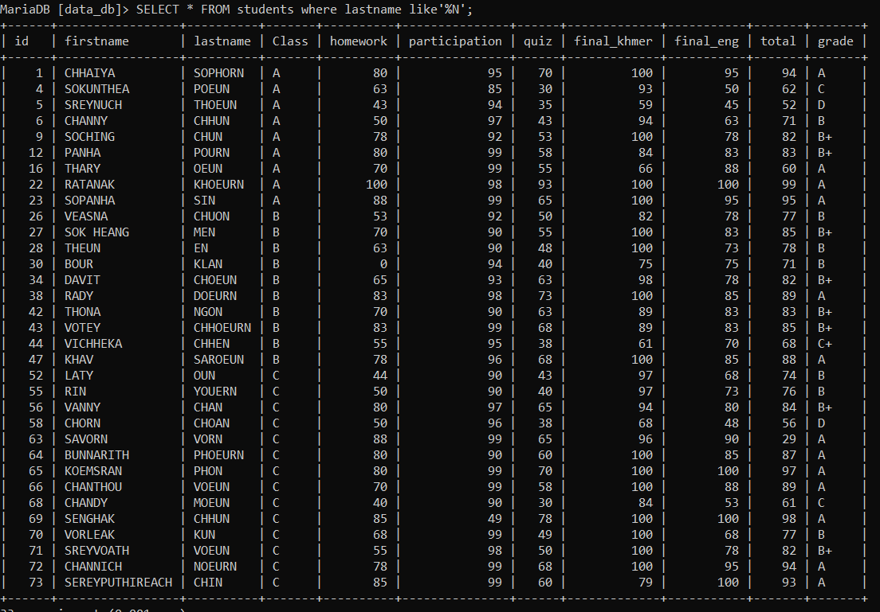Get all students who have first name start with letter “S”

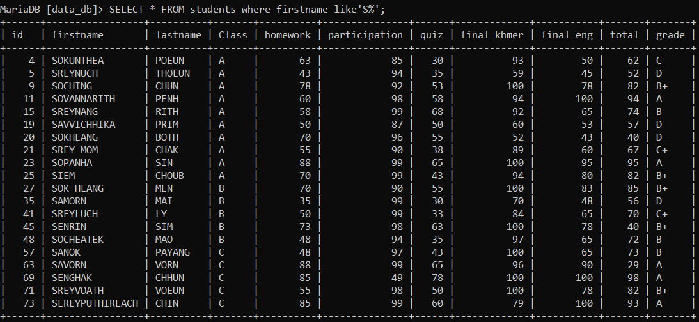

1. Get only students who has grade A from class B display only firs name , last name and grade

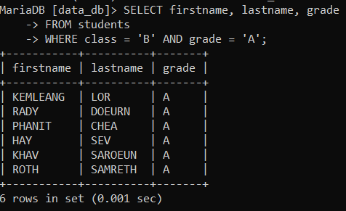

1. Sum all score for Vorleak

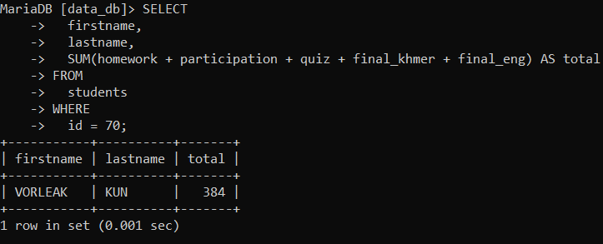

1. Update Pheaktra and Sanok from class C to class B

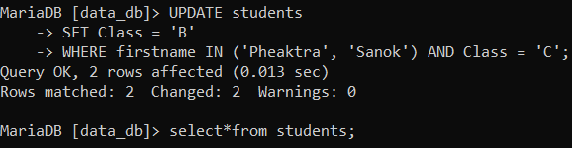

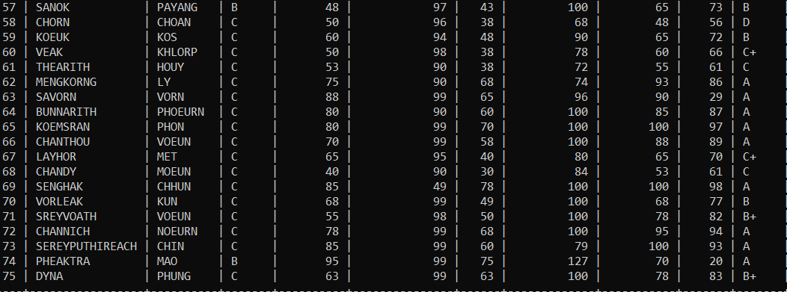

10 - How many students get grade A?

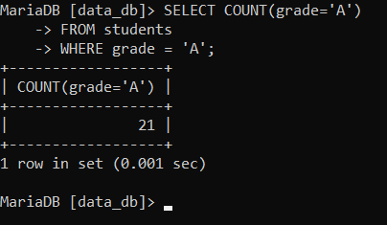

11 - Delete all students who failed quiz

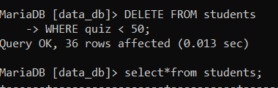

12 - merge firstname and lastname to one column

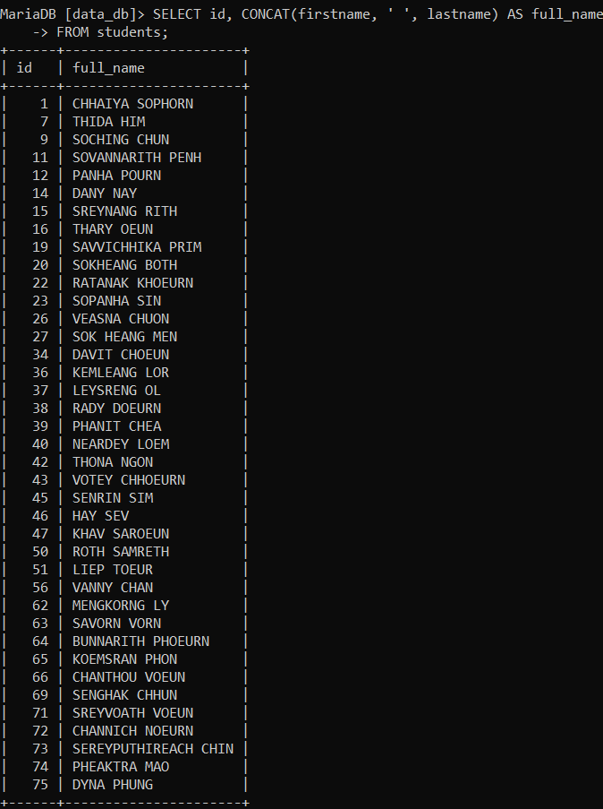13 - Get first 10 students from the list

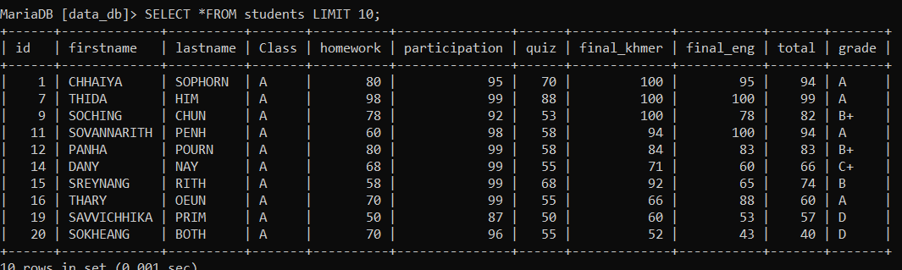

14- Get average total score from the list

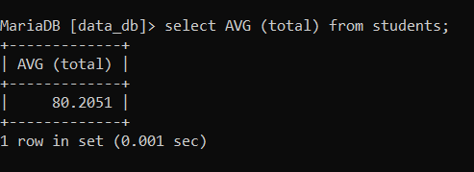

15- Get all who have total score less than average score of the list

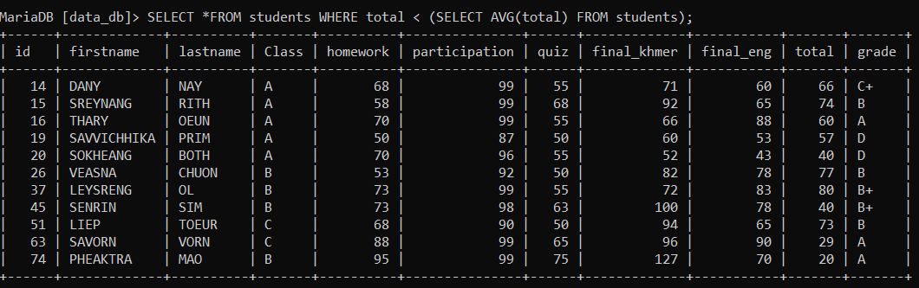

16- Get all who have total score equal maximum score in the list

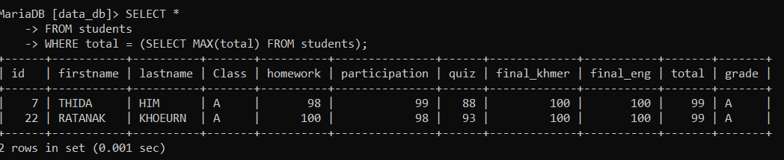

17- Get all who have quiz score equal miximum score quiz in the list

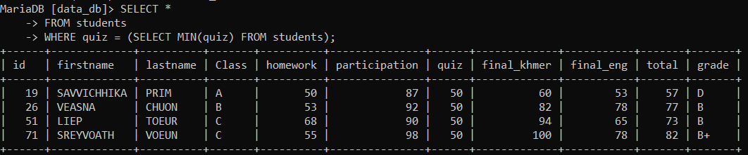

18- Get all students who have maximum score equal total and quiz score less than average quiz score

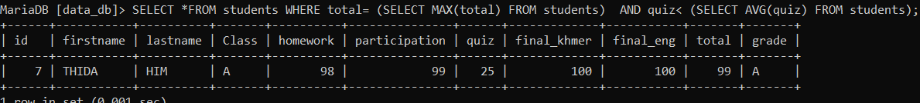

19- Get all student order by last name desc

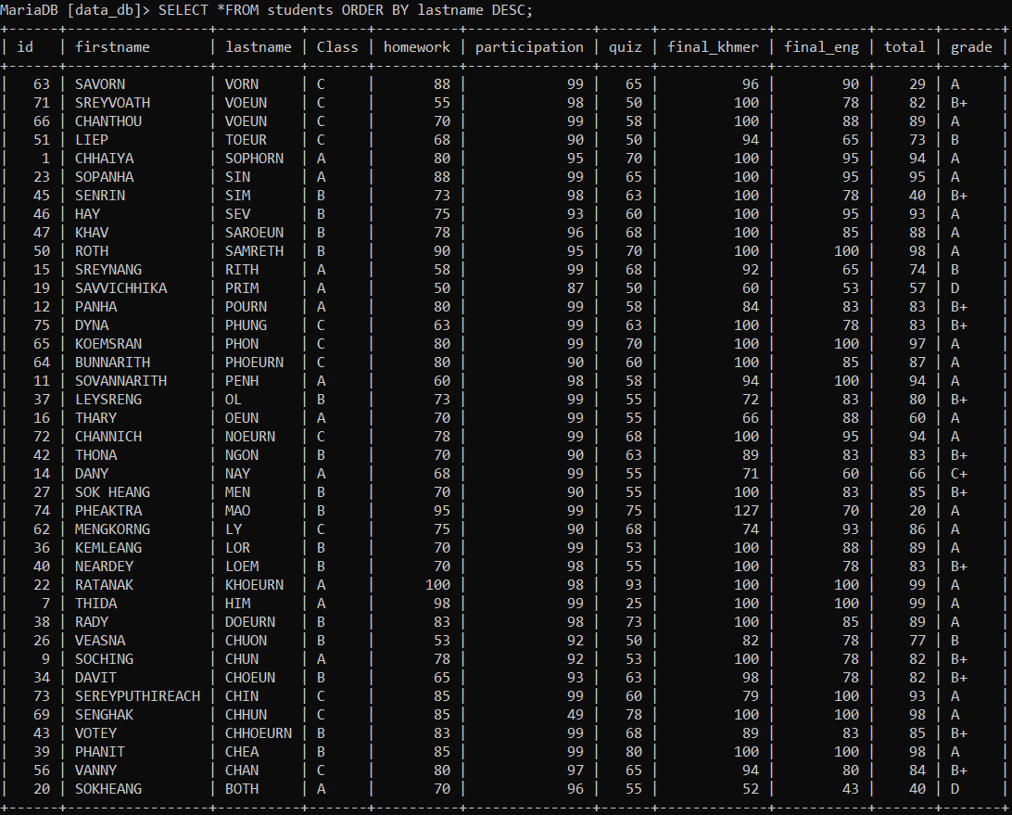

20- Get unique grade from table

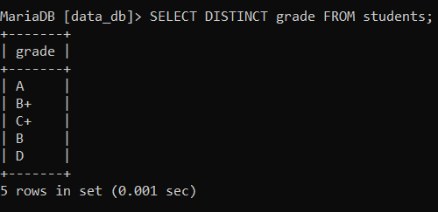

21- Get firstname , lastname of students and group by class

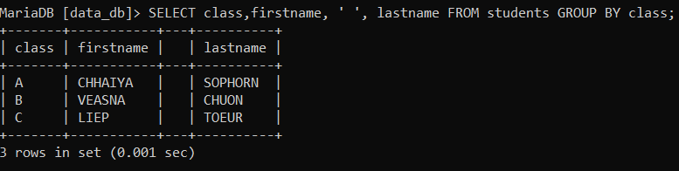

22- Get full name, homework, and quiz, total

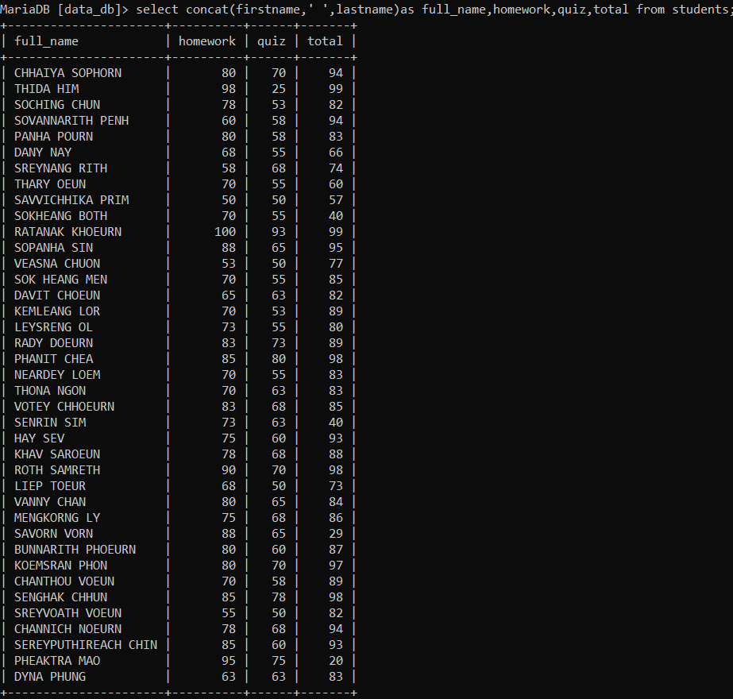

23- Delete who has first name start with letter ‘C’

